Missing Birth_Weight(grams) Analysis Report
Generated: 2026-03-21 11:58
Dataset: 336,097 rows × 18 columns
Target Variable: Birth_Weight(grams)

1. Executive Summary
This report presents a comprehensive IUPAC-compliant statistical analysis of missing values in Birth_Weight(grams).
Key findings include:
• Missing records: 33,604 (10.0% of total data)
• Variables with significant differences (p < 0.05): 12
• Total variables analyzed: 17
• Numeric variables: 7
• Categorical variables: 11
Based on the statistical analysis, the missingness pattern is classified as:
• SYSTEMATIC PATTERN - Missing data is strongly associated with other variables

2. Statistical Summary
Metric | Value
Total Missing Birth_Weight(grams) Records | 33,604
Missing Percentage | 10.00%
Total Variables Analyzed | 18
Numeric Variables | 7
Categorical Variables | 11
Variables with Significant Differences | 12
Analysis Date | 2026-03-21

3. Variables with Significant Differences
The following 12 variables show statistically significant differences (p < 0.05) between missing and complete groups:
Variable | Data Type | Test | p-value
Registered_Month | str | χ² test | 0.0000
Registered_District | str | χ² test | 0.0000
Birh_Year | int64 | t-test | 0.0000
Birth_Month | str | χ² test | 0.0000
Birth_Year_2.0 | int64 | t-test | 0.0000
Hospital or Not | str | χ² test | 0.0000
TWIN | int64 | t-test | 0.0000
Birth_Order | str | χ² test | 0.0000
Marital_Status | str | χ² test | 0.0000
District_of_Mother | str | χ² test | 0.0000
Race_of_Mother | str | χ² test | 0.0000
Race_of_Father | str | χ² test | 0.0000

4. Statistical Visualizations
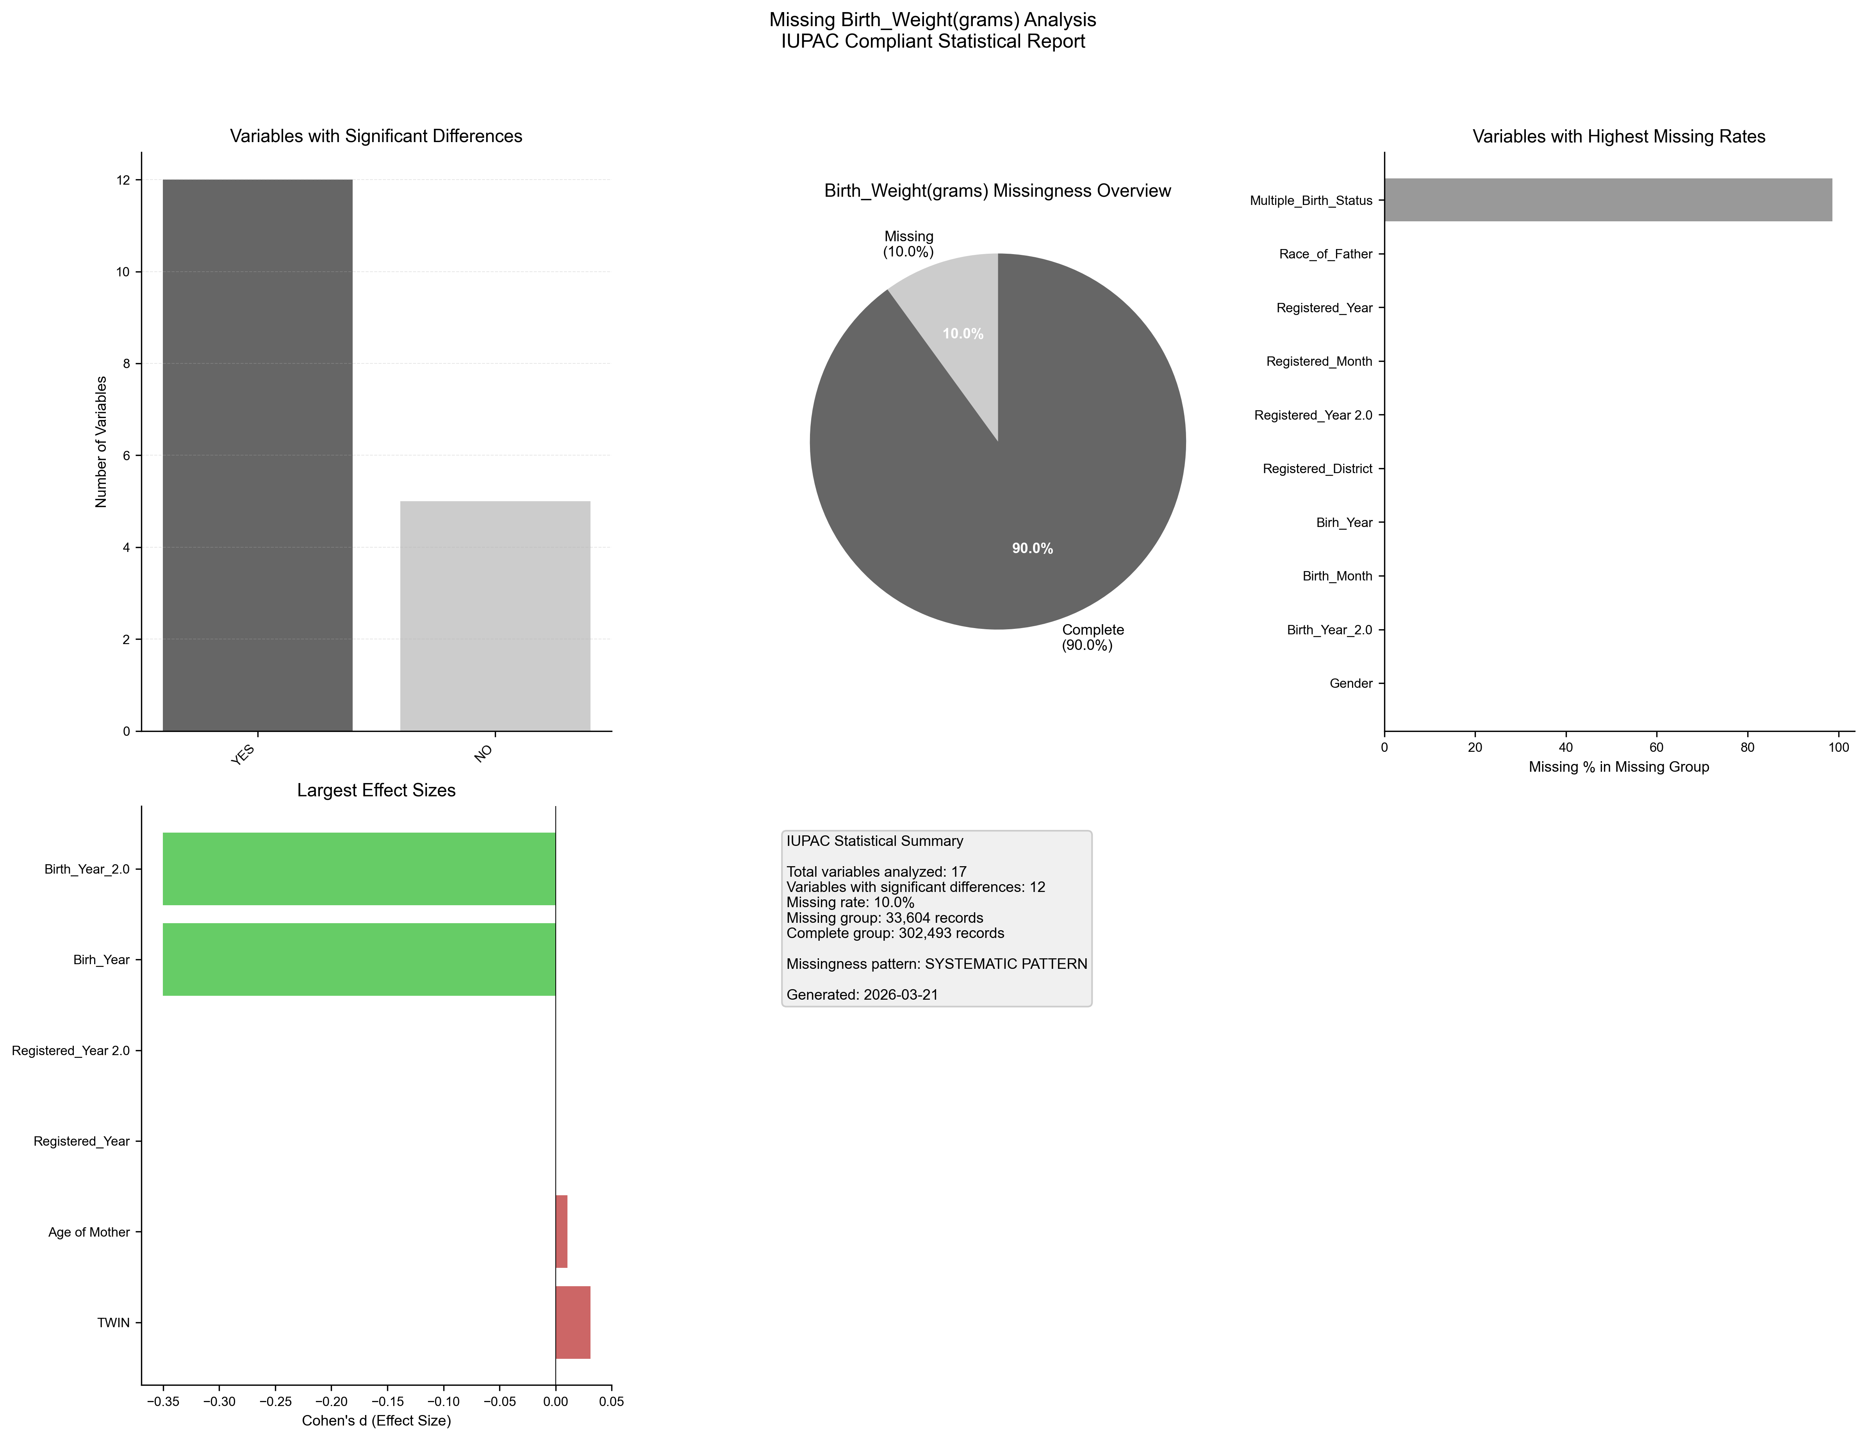
Figure 1. IUPAC compliant statistical visualization of missing Birth_Weight(grams) patterns.

5. Recommendations
- Based on the statistical analysis, the missing data exhibits SYSTEMATIC patterns:
- Consider treating missing as a separate category in analysis
- Use multiple imputation methods (MICE, EM algorithm)
- Investigate the variables with significant differences for common themes
- Document missingness patterns in methodology section

6. Methodology (IUPAC Compliant)
Analysis performed according to IUPAC guidelines for data presentation:
- • Missing values reported as both count (n) and percentage (%)
- • Tables formatted with thin borders and alternating row shading
- • Sans-serif fonts (Arial) used for optimal readability
- • Statistical tests: t-test (numeric), χ² test (categorical)
- • Effect sizes: Cohen's d for numeric, Cramer's V for categorical
- • Figures saved at 300 DPI for publication quality
- • All outputs include metadata with generation date

